**DAILY ONLINE ACTIVITIES SUMMARY**

|  |  |  |  |  |  |  |  |
| --- | --- | --- | --- | --- | --- | --- | --- |
| **Date:** | **21/05/2020** | | | | **Name:** | **Prashant Rama Bhat Kodlekere** | |
| **Sem & Sec** | **4rd sem (B sec)** | | | | **USN:** | **4AL18CS060** | |
| **Online Test Summary** | | | | | | | |
| **Subject** | | **MICROCONTROLLERS AND EMBEDDED SYSTEM** | | | | | |
| **Max. Marks** | | **30** | | **Score** | | **16** | |
| **Certification Course Summary** | | | | | | | |
| **Course** | **Data structure and algorithms(2ND session)** | | | | | | |
| **Certificate Provider** | | | **Udemy** | **Duration** | | | 28.5 total hours |
| **Coding Challenges** | | | | | | | |
| **Problem Statement: .** [Write C Program to create Singly Liked List with n elements and reverse the elements using C.](https://github.com/orgs/alvas-education-foundation/teams/2nd-year/discussions/71)  Top of Form  Bottom of Form | | | | | | | |
| **Status:Completed** | | | | | | | |
| **Uploaded the report in Github** | | | | **YES** | | | |
| **If yes Repository name** | | | | **https://github.com/prashantkodlekere/codingactivity** | | | |
| **Uploaded the report in slack** | | | | **YES** | | | |

Online Test Details:

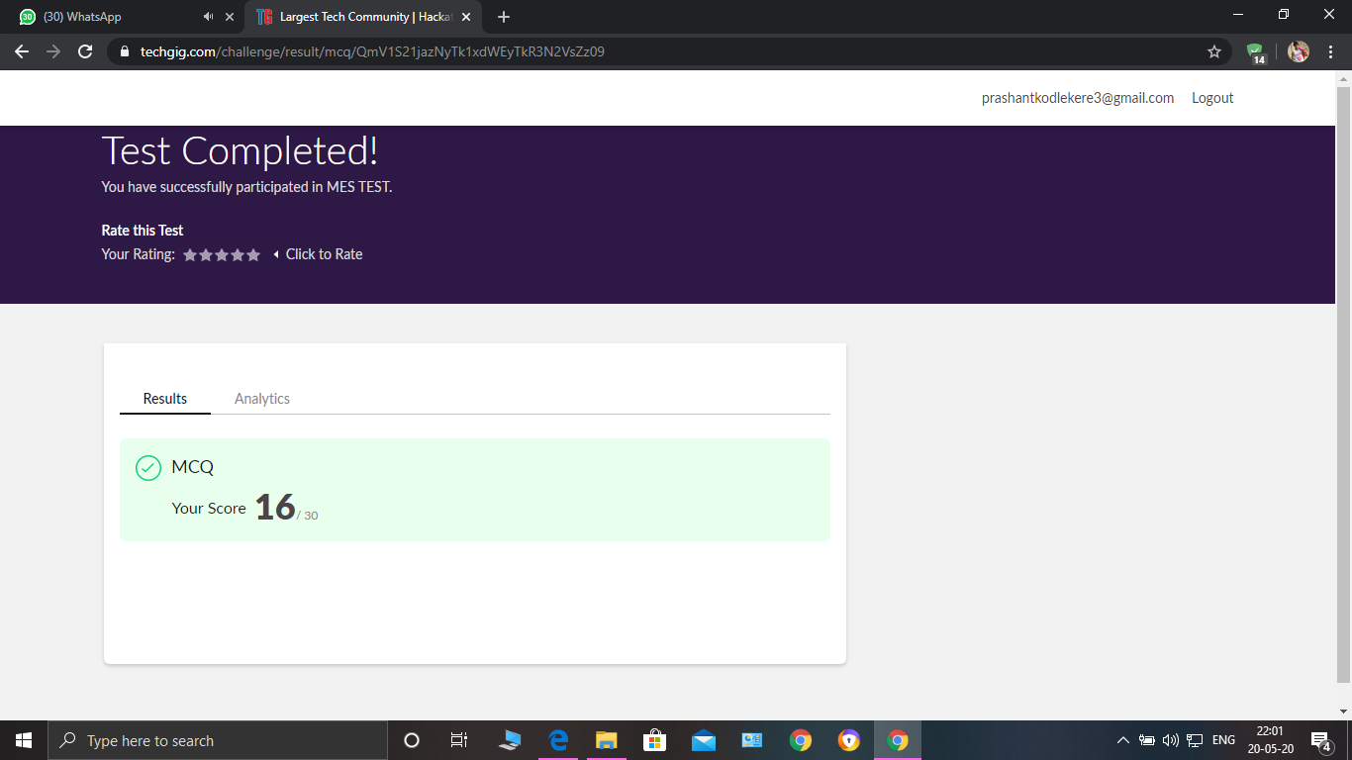

MICRO CONTROLLERS AND EMBEDDED SYSTEM Internals was conducted. A total of 30 questions were there in

which were Multiple Choice Questions.

The above snapshot is the result sheet which was mailed to us by the Techgig team.

Certification Course Details:

Course name:data structures and algorithms.(2nd session)

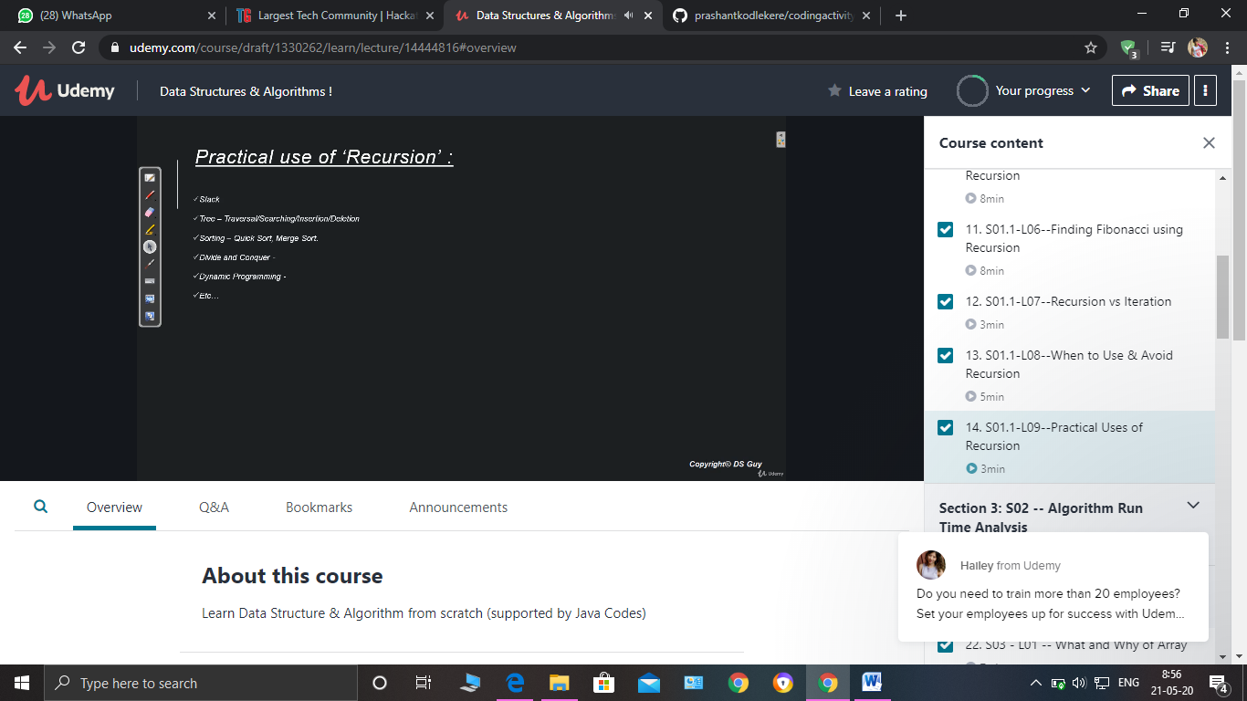

Today..I learnt concept of Recursion.

What is recursion and Why to use the Recursion.

And learnt some programs like Fibonacchi and Factorial of a number using that concept.also learnt when to use Recursion and its practical uses..and difference between recursion and iteration.

Coding Challenges Details: (Attach the snapshot and briefly write the report for the same)

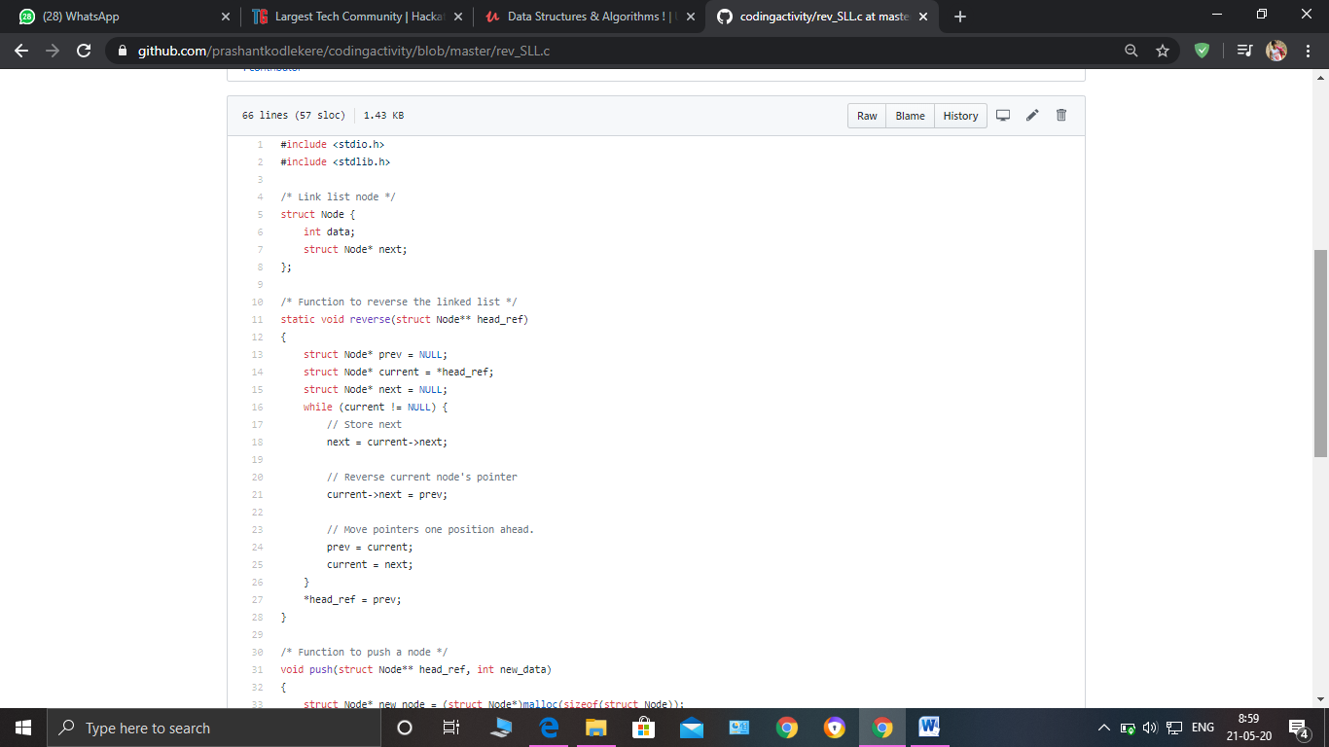

**The question I took to code is:**

[Write C Program to create Singly Liked List with n elements and reverse the elements using C.](https://github.com/orgs/alvas-education-foundation/teams/2nd-year/discussions/71)

Top of Form

Bottom of Form

|  |
| --- |
| Hint: Create the SLL, and then Reverse the Link in SLL until Head becomes NULL. Each Time Reversing the Link, Head must be moved to next immediate node. |

Code: The above snapshot is the code which I have uploaded in my Github repository.